# Lab 5

## Theory

## Methodology

Task A5 consists of designing a temperature-to-voltage converter for a thermistor-based measurement system. The temperature range for this application is $-25°C to 180°C$. The thermistor used in this application is the NTCLG100E2. According to the datasheet, the range of this thermistor is $-40°C to 180°C$, this means that it will work for this application as it is within the required range.

The temperature-to-voltage converter that was built consisted of a Wheatstone bridge and an instrumentation amplifier. The initial output voltage of the Wheatstone bridge is 0, with changing temperature the thermistor changed resistance. The instrumentation amplifier calculated (analogue arithmetic) the difference between the voltages in the two branches of the bridge, the output was then tabulated, and a graph was made showing the resulting output voltage with changing temperature.

A design specification for the temp-voltage converter was that temperatures above $25°C$ must give a positive output voltage while the temperatures below $25°C$ must give a negative output.

One initial assumption made was that the temp-voltage converter was controlled by a microcontroller, specifically, an Arduino UNO. The output voltage from any pin of the UNO is 5V. The gain of the instrumentation amplifier was also assumed, based on the 5V coming from the Arduino, the output by definition could not be greater than 5V or less than -5V; a gain was used that accommodated the maximum and minimum output voltages of the bridge

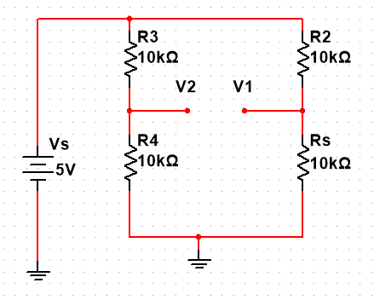

Figure shows the Multisim schematic of a Wheatstone bridge using the NTCLG100E2 thermistor as a sensor. The thermistor, Rs=R+ $∆R$, according to the datasheet, one of the resistance values that gives an output voltage of 0V, is 10kΩ ($±5\%$); $∆R$ is the change in temperature of the thermistor, this was used as the reference (at $25°C$ $∆R$ = 0Ω).

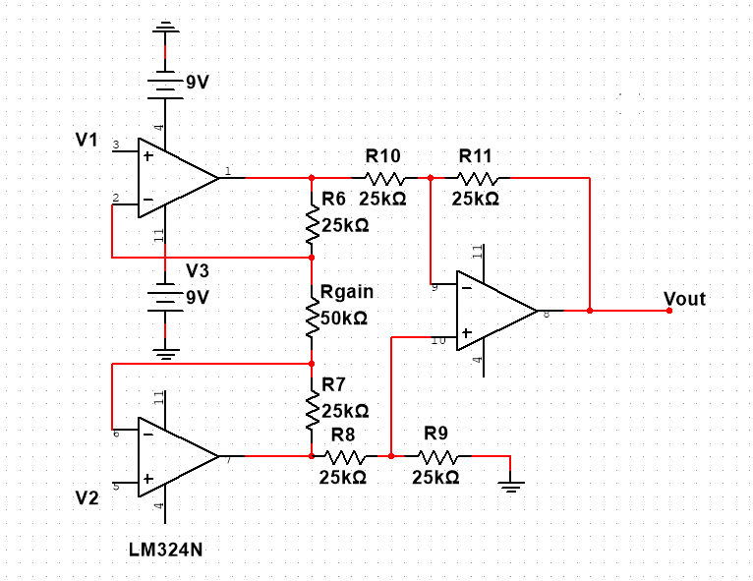

Figure shows the Multisim schematic for the Instrumentation Amplifier (INA) for the temp-voltage converter. V1 and V2 are the inputs and Vout is the output voltage.

**Design specifications**

* Quad LM324N OP-AMP
* $±$ 9V supply voltage

**Assumptions**

$R6=R7=R8=R9=R10=R11=25kΩ$

$\frac{V_{out}}{V_{1}-V_{2}}=2$

## Results and Analysis

Eqs. prove using voltage dividers that v1-v2 intially is equal to 0, then changes when the thermistor resistance, Rs, changes.

|  |  |
| --- | --- |
| $$V1=\frac{R}{R+R_{s}}×V_{s}$$ | () |
| $$V1=\frac{10000}{10000+10000}×5$$ | () |
| $$V1=2.5 V$$ | () |
| $$V2=\frac{R}{2R}×V_{s}$$ | () |
| $$V2=\frac{10000}{2×10000}×5$$ | () |
| $$V2=2.5 V$$ | () |
| $$V_{12}=V_{1}-V_{2}=2.5-2.5=0 V$$ | () |

Figure shows the graph of the temperature vs output voltage.

Figure shows the output voltage vs resistance graph of the thermistor. This graph was also made using the data from the datasheet of the thermistor as well as the calculations for $V_{out}=V1-V2$ calculated earlier for the voltage vs temperature graph.

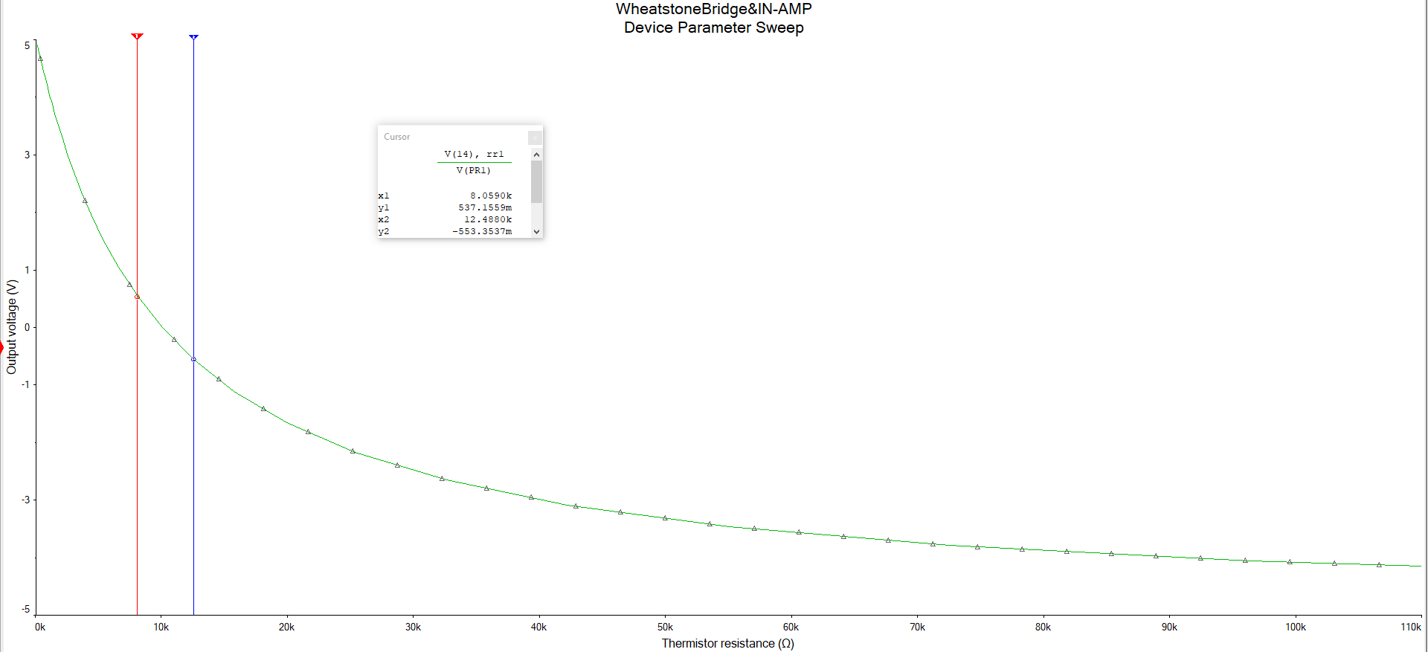

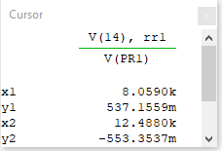

Figures and show the parameter sweep that was done on Rs, the thermistor. The values sweeped were the values of the total resistance (R+deltaR) given for each temperature by the datasheet; from -25*C to 180*C. The graph that is made by multisim is a voltage vs resistance graph, like the one made on excel with the data from the datasheet.